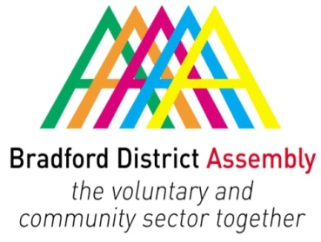
Forum/Assembly Representative
Feedback Report

Please provide a brief summary of meetings you have attended on behalf of the Assembly/VCS Forum. This report will be used to inform the Assembly Steering Group/Forum that you represent. The information contained within it will be posted on the Bradford Assembly website www.bradfordassembly.org.uk. If you wish to report on something confidential, please mark this clearly.
Return your completed form to wendy@cnet.org.uk

Name of Representative  E mail / contact details  Title of the board / group you sit on  Date the meeting took place  Date of next meeting  Did you receive the meeting papers in time to have a pre-meeting? | Kim Shutler-Jones  Kim.shutler-jones@thecellartrust.org  A&E Delivery Board  18.10.18

- I have negotiated that VCS would receive free flu jabs for front line staff working with vulnerable people. National dictate is that it is meant to be CQC registered orgs only but BMDC have agreed to support (thanks to Lyn Sowray and Toni Williams). Providers will need to give an indication of how many staff have had the jabs. Details are being finalised around how this will work but most likely to be a voucher scheme.
- Better Care Fund additional winter money (£2.297m locally announced today by Matt Hancock) – this is mostly going to be supporting reducing length of stay but some of the funding may be used to pilot Carer Navigators and associated comms – which is likely to build on the planned work with Carer’s Resource. Ideas so far are:
  - Inc. dom. care support but also address existing overspend
  - Investment therapy in care homes and once discharged (OT)
  - Potential additional social care and AMHPs – to work with Peer Support Workers including working with older people
  - Support for people in crisis living with dementia
Bradford are actually doing very well on delayed transfers of care compared to national picture. Lyn S is going to pull together a plan. In the main it will be top ups of things doing already or are things identified which hasn’t been fundable previously. I will pick up with Lyn if there are any opportunities for the VCS in this. Proposals will be finalised at the Urgent Care Board.
- I raised whether the VCS orgs operating as part of the scheme can be added onto a collective agreement so that they don’t have to do individual Hon Contracts which can be time consuming.
- There was a discussion around how we get some messages out around winter across our communities – that are collective rather than from individual organisations. It would be good if individual VCS could be proactive in terms sharing messages as we know that we have good engagement with local communities. Can we think about some coordinated messages so that we have something which collectively raises awareness of the VCS. Maybe some sort of ‘Did you know?’
- There has been a lack of flu jab supply which is specific for the over 65s – this is a national year. There will be a targeted campaign in terms of vaccination of people with respiratory illness.
- It has been agreed that Urgent Care leaders will participate in a ‘Walk in My Shoes’ scheme which will see leaders spending time in other parts of the system. Some of the leaders have asked to visit VCS organisations. Rebecca Malin (CCG) will be coming to Youth in Mind and Stacey Hunter (AGH) will be coming to Sanctuary at Mind in Bradford and Carer’s Resource. I will put people in touch with requested VCS organisations. If VCS leaders would like to do this reciprocally then let me know and I am happy to set up connections. For example, it would be worthwhile for orgs working closely with stat orgs.

