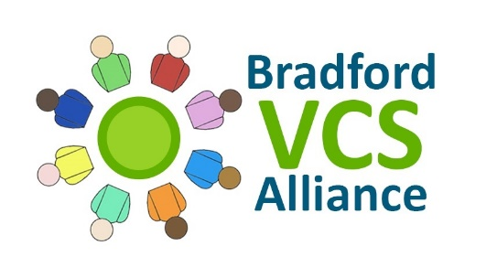
Update Report for the Health and Wellbeing Forum
December 2018

This report provides some highlights from BVCSA of developments and progress over the last 3 months.

- Strategic Engagement

  - Exploring VCS Representation in AWC
Over the autumn, BVCSA was asked to facilitate two partnership workshops to help the local VCS and AWC CCG to understand the current arrangements for VCS Representation and to identify ways that this could be more co-ordinated and improved. Arrangements for the future are being developed jointly with the aim of implementing improved arrangements early in 2019.

  - Diabetes Pathway Planning Group
BVCSA has been actively engaged over the last few months in the strategic work to develop an improved and more collaborative multi-agency approach to tackling the challenge of Diabetes in Bradford. BVCSA has helped to identify opportunities for the local VCS to overcome barriers for patients to engage with vital early support.

  - Strategic Partnering Agreement
The principles underpinning the Partnership Operating Framework have now been agreed, and work has progressed to developing a single Strategic Partnering Agreement for both Bradford and AWC. BVCSA has been leading the contribution of the VCS into this process in both areas and has worked closely with a range of different partner agencies to negotiate the future status and role of the VCS. BVCSA has endeavoured to keep interested VCS organisations updated by presenting on progress made at the Bradford VCS Health and Wellbeing Forum, the AWC Health and Wellbeing Hub and the Craven VCS Delivery Partnership.

- Contract Delivery

  - Harnessing the Power of Communities - AWC and Bradford
Early in the autumn, BVCSA was approached by the CCGs to develop and lead a partnership project to meet the requirements of the Harnessing the Power of Communities Fund through the West Yorkshire and Harrogate Health and Care Partnership. The project aimed to help tackle loneliness, reduce health inequalities and to improve system performance.

A very short timeframe was afforded to develop and submit the proposal. BVCSA worked closely with the Local Authorities, CCGs and local VCS organisations to identify local and immediate needs, focussing on low-level Mental Wellbeing Support in AWC, and Befriending across the Bradford Local Authority area.

In AWC, BVCSA worked closely with Craven VCS Delivery Partnership to build on their existing Mental Wellbeing programme, by facilitating its expansion to both Airedale and Wharfedale, in line with locally agreed priorities. BVCSA is co-ordinating the four VCS Delivery Providers to establish 10 ‘hublets’ across AWC as Health and Wellbeing Peer Support Groups, and to provide Workforce Development through a menu of Mental Wellbeing training for VCS staff and volunteers.

In Bradford, BVCSA has worked closely with Bradford Befriending Network to commission a Research Study into strategically understanding the scope and value of Befriending Services for Bradford, working with Adult Social Care to identify potential future demand, and developing potential new partnerships through Primary Care. The project is also supporting the development of the Network itself, identifying and establishing a potential menu of training to help to upskill local VCS services, and enabling Providers to trial Innovative Approaches to Befriending.

The project will be delivered and evaluated by the end of March 2019.

  - Diabetes Prevention Programme and Diabetes Management Programme
The Bradford Diabetes Prevention Programme has reached our first significant landmark, when one of our first patients we’ve worked with has now reversed their pre-diabetic diagnosis. Several other patients have worked hard to reduce their weight by over 5%, and increase their levels of exercise, alongside adopting healthier eating habits.

Our Diabetes Management Programme has now seen 60 people receive support to overcome barriers to accessing Structured Education to learn to manage their Diabetes for themselves. BVCSA has been working closely with Structured Education Providers to explain and signpost the options available for Patients, and to provide personalised support to those who want it.

  - Health Messaging
Our 2018 Health Messaging Project has continued to disseminate 3 key messages across the whole of Bradford District and Craven:
    - Choose Well (Health Literacy)
    - Flu Vaccinations
    - Mental Health (‘It's ok to not be ok, and if you're not ok, tell someone’)

Our second round of applications funded a further 24 projects, resulting in BVCSA working with over 50 projects across the area.

Asset Based Community Development - Small Grants Fund
BVCSA has recently completed the first round of Asset Based Community Development (ABCD) small grants funding in Bradford, with the aim of supporting and activating a range of grassroots community activities and ideas which will improve the health and wellbeing of local people.

120 applications were received and reviewed by local Panels comprising representatives from Community Partnerships, local Ward Officers or Councillors, local Businesses, and members of the local Community. 99 projects have been funded, with all applications receiving written feedback from their respective Panels.
- Organisational Development
BVCSA is now in the process of finalising its Provider Handbook, which will contain full details of its Vision, Values, Mission, Aims and Objectives, as well as its operating principles and contracting processes. The BVCSA Board have worked hard over the autumn to work through, and agree these important principles. Negotiations are still ongoing with the CCGs to finalise the Information Governance requirements required Providers.

For any questions or comments, please contact:

Ben Cross - Programme Lead - ben@bradfordvcsalliance.org.uk - 07598 052857

