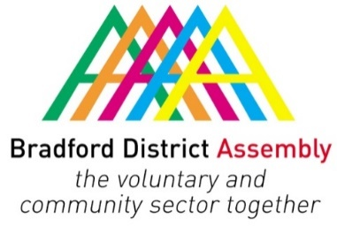
Bradford & District Community Economic Forum (CEF)
Monday 9 November 2020
10.00 – 11.30 am via Zoom

Agenda

10.00 Welcome and apologies
10.05 Economic Strategy, overview and impact of Covid-19
- Mark Clayton, Policy Officer, Office of the Chief Executive, Bradford Council

10.20 Bradford Economic Recovery Board
- Professor Zahir Irani, Pro-Vice Chancellor, University of Bradford / Chair, Bradford Economic Recovery Board

10.50 West Yorkshire Devolution / Combined Authority
- Jamie Saunders, Policy Officer, Office of the Chief Executive, Bradford Council

11.10 Minutes of the last meeting and matters arising

11.20 AOB

Note:
- Declarations of interest to be declared against each agenda item as appropriate
- Equalities: Discussions/decisions/issues that may have a disproportionate effect on protected characteristics to be raised against each agenda item as appropriate

