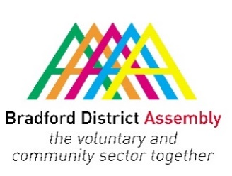
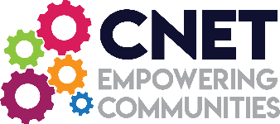

Bradford District Assembly Safer Communities Forum:
Anti-Social Behaviour in the Bradford District
Monday 26 July 2021
10.00 am – 12.30 pm

Agenda
(Approx. Times)

10.00 Welcome / the work & role of the Safer Communities Forum
- Co-chair Jon Royle, CEO, The Bridge Project

10.15 Presentations from:

- Meena Jeewa, Project You Turn Programme Manager – a Community drugs prevention programme for BD7, funded by Big Local
- Kyra Dobson, The Bridge Project – sharing her story of her journey from addiction to recovery (introduced by Jon Royle)
- Michael Churley – Bradford Metropolitan Council’s Community Safety Coordinator
- PC Caroline Foster – Bradford East Anti-Social Behaviour Officer
- Gemma Gibbs – Crimestoppers UK

11.45 Discussion groups – break out into groups and discuss the following:

- What projects, initiatives or schemes are you either involved in or know of, that tackle the issues of Anti-Social Behaviour, or are working to prevent Anti-Social Behaviour before it occurs?
- Where are the gaps and how can ASB related issues be tackled pro-actively?

12.00 Feedback

12.15 Closing Remarks
- Co-chair Yasmin Khan, CEO, Staying Put

12.30 Close

