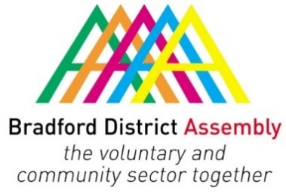
Bradford Environment Forum (BEF)
Thursday 23 September 2021
10.00 am – 12.00 pm, Inspire Business Park and Zoom

Agenda

- Welcome and apologies
  - Carlton Smith, BEF Chair
- Minutes of last meeting and matters arising
- Bradford 2025 UK City of Culture Bid
  - May McQuade, Programme & Community Co-ordinator
- The Leap Bradford
  - France–Leigh Hadrysiak
- Artworks Creative Communities
  - Estelle Cooper, Project Coordinator
- Cecil Green Arts
  - Judy Connor
- Members news
- Date and subject of next meeting

Note:
- Declarations of interest to be declared against each agenda item as appropriate
- Equalities: Discussions/decisions/issues that may have a disproportionate effect on protected characteristics to be raised against each agenda item as appropriate

